**BANK APPLICATION DOCUMENTATION**

1. **Log in page:**

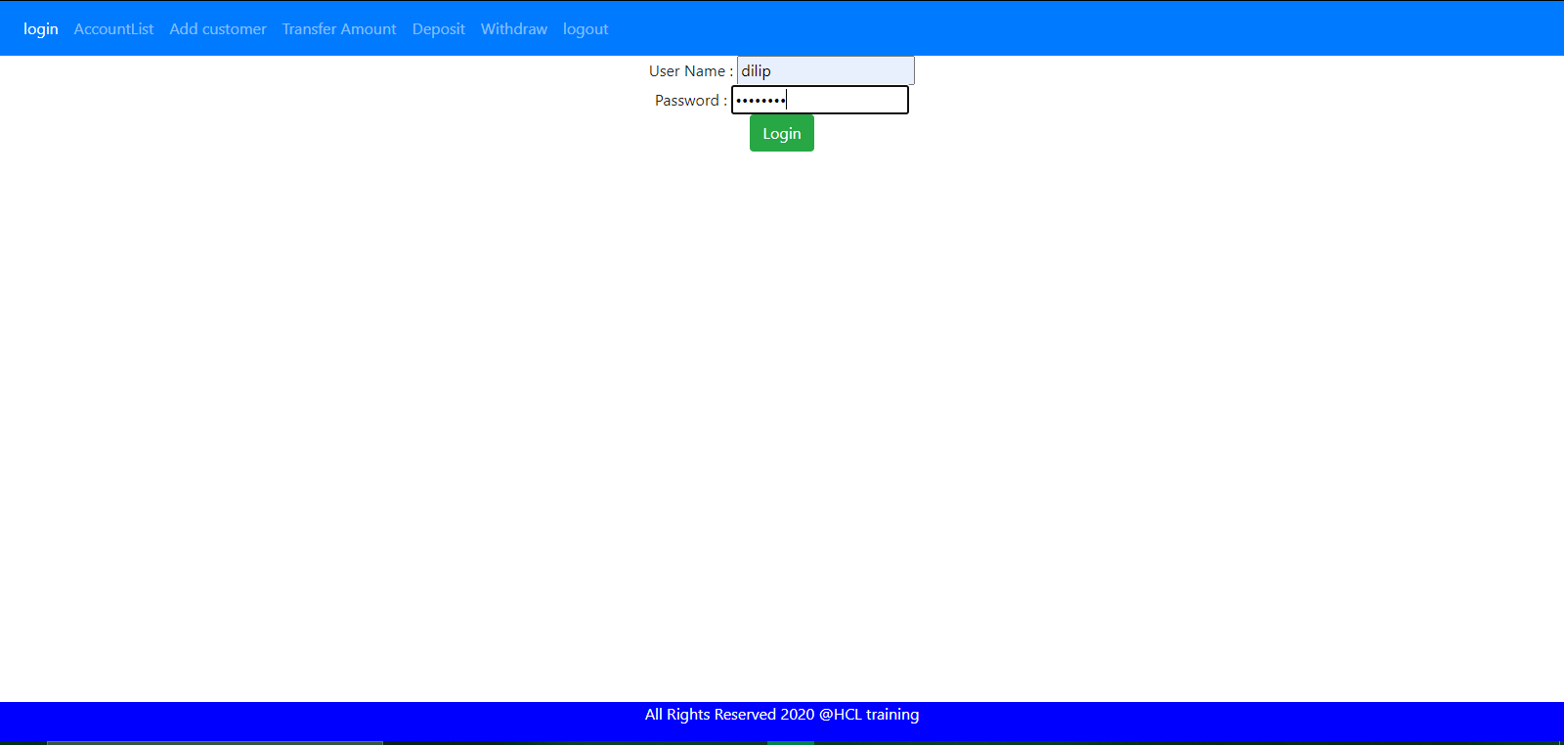

1. **After Log In the total accounts list are given below:**

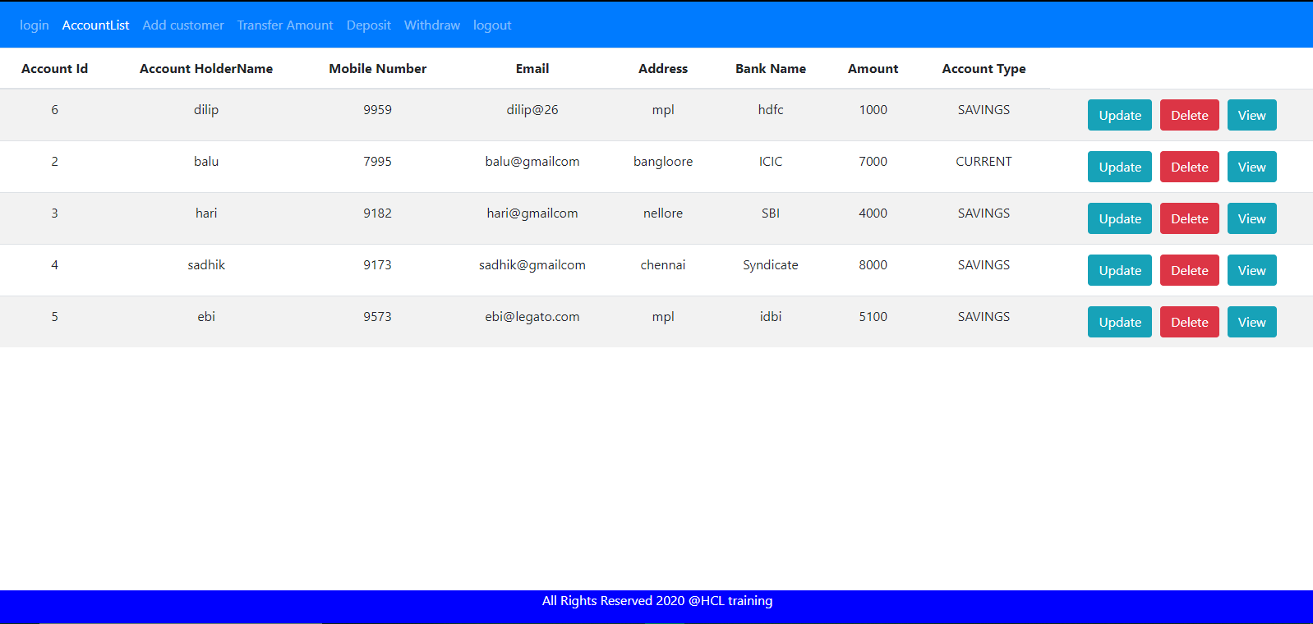

1. **Creating a new Customer account:**

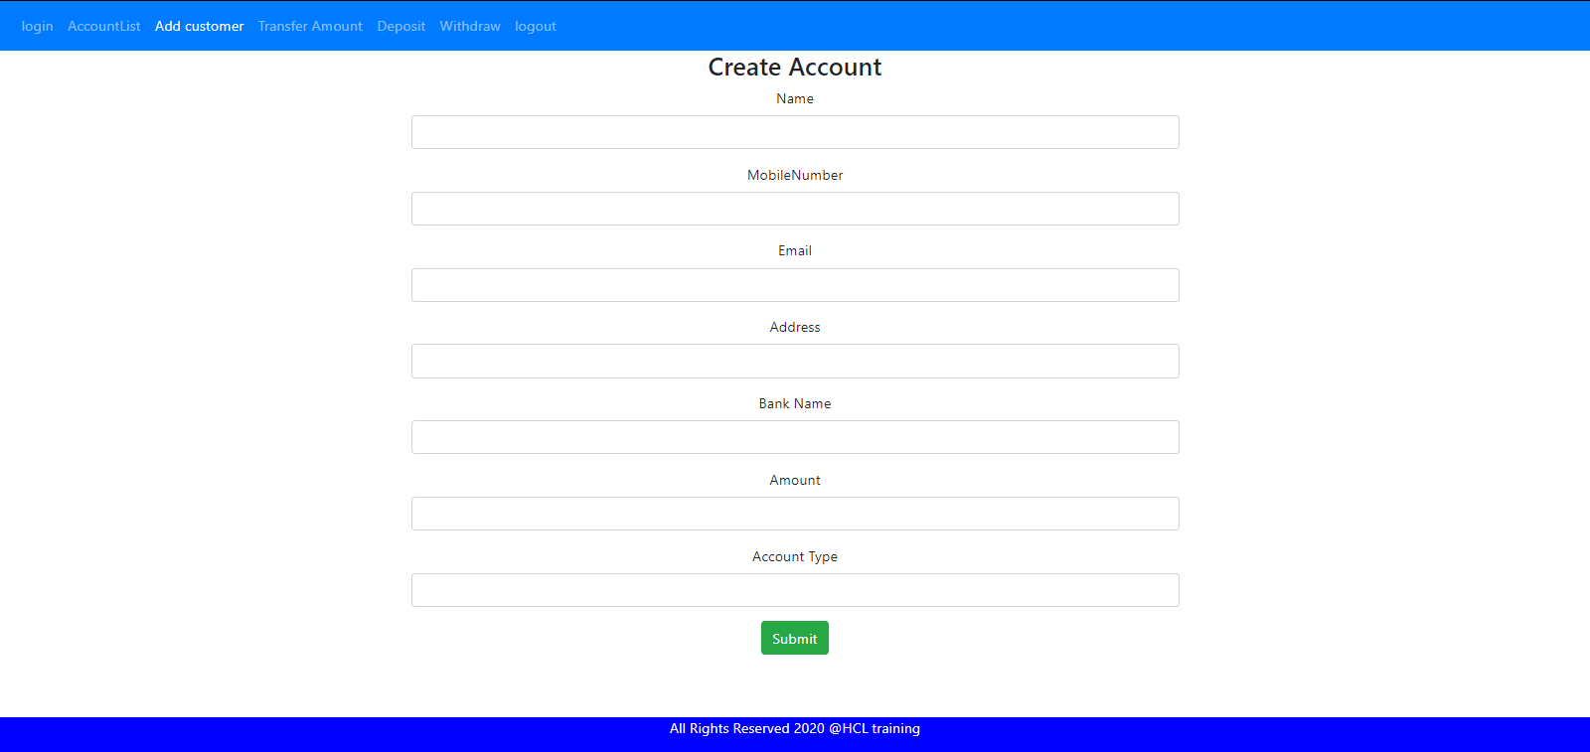

1. **After adding new customer total accounts list are:**

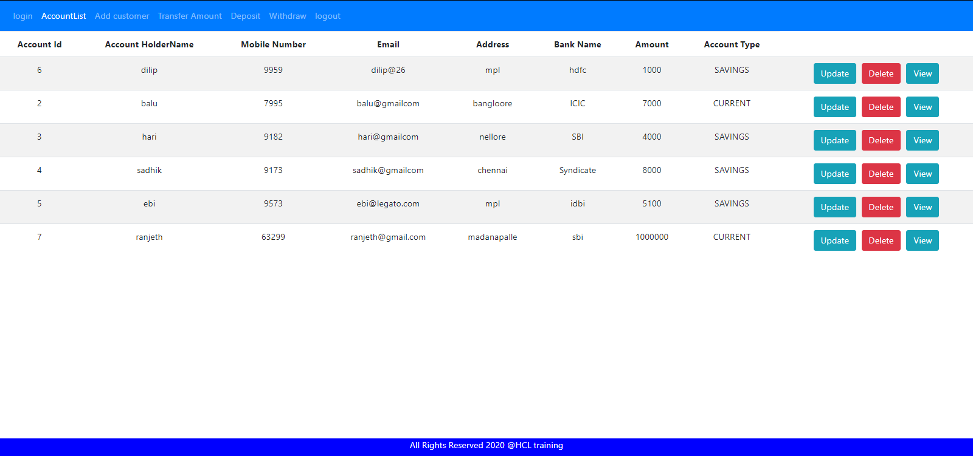

1. After updating the account details in Id:7

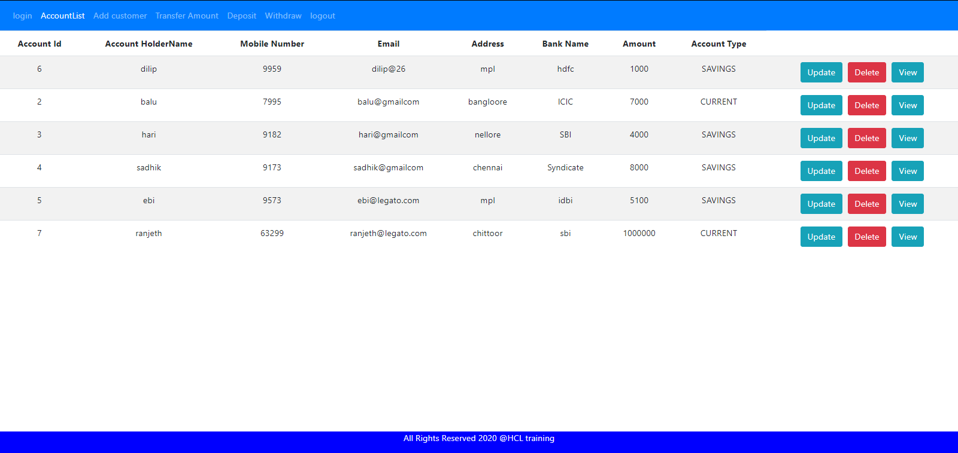

1. **Viewing account details by id**

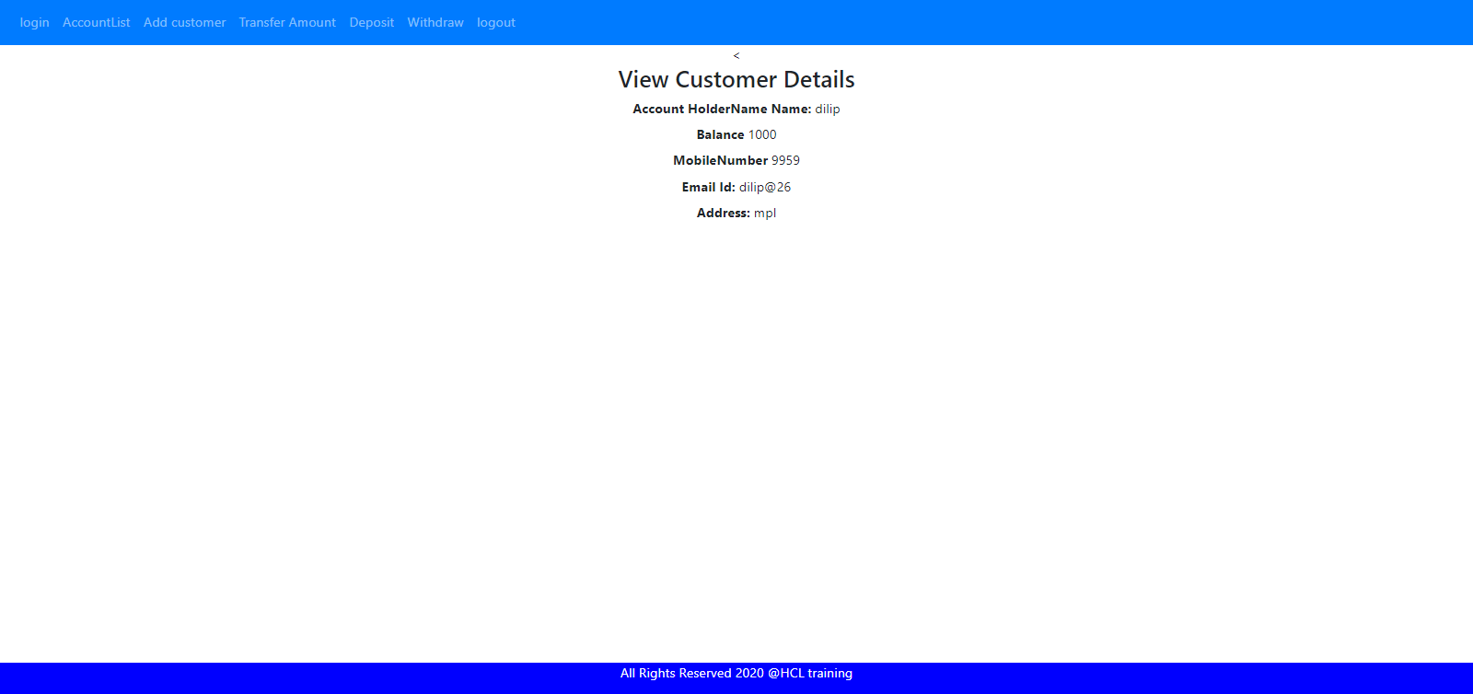

1. **Transferring the amount from One Id to another Id**

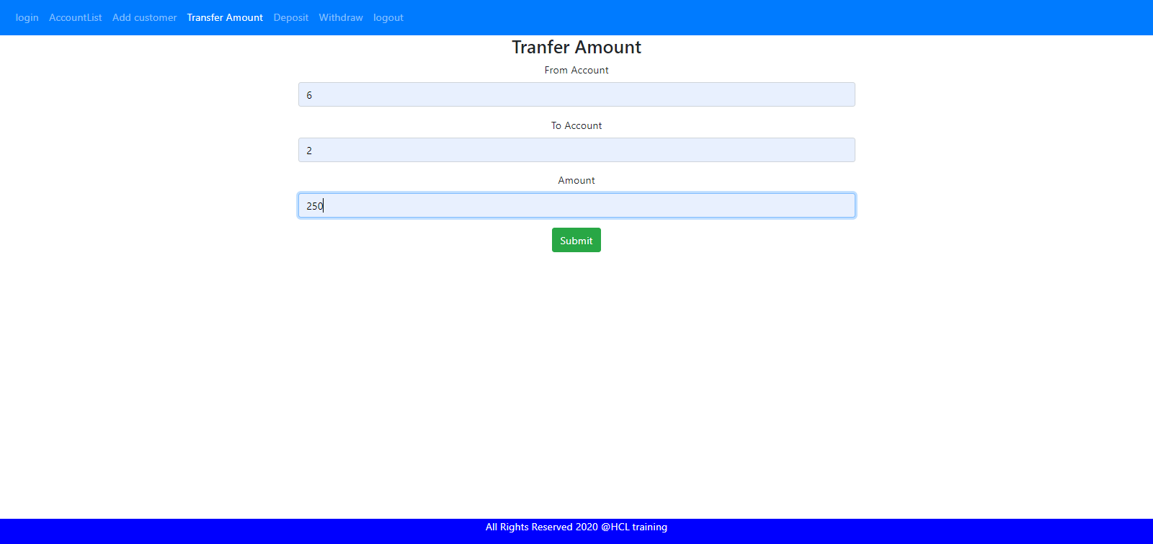

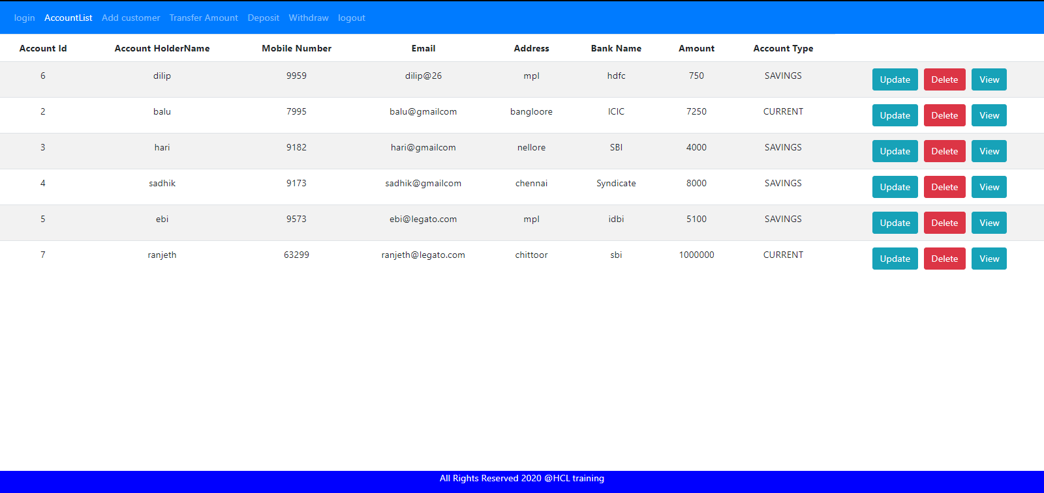

1. Depositing the amount using Id

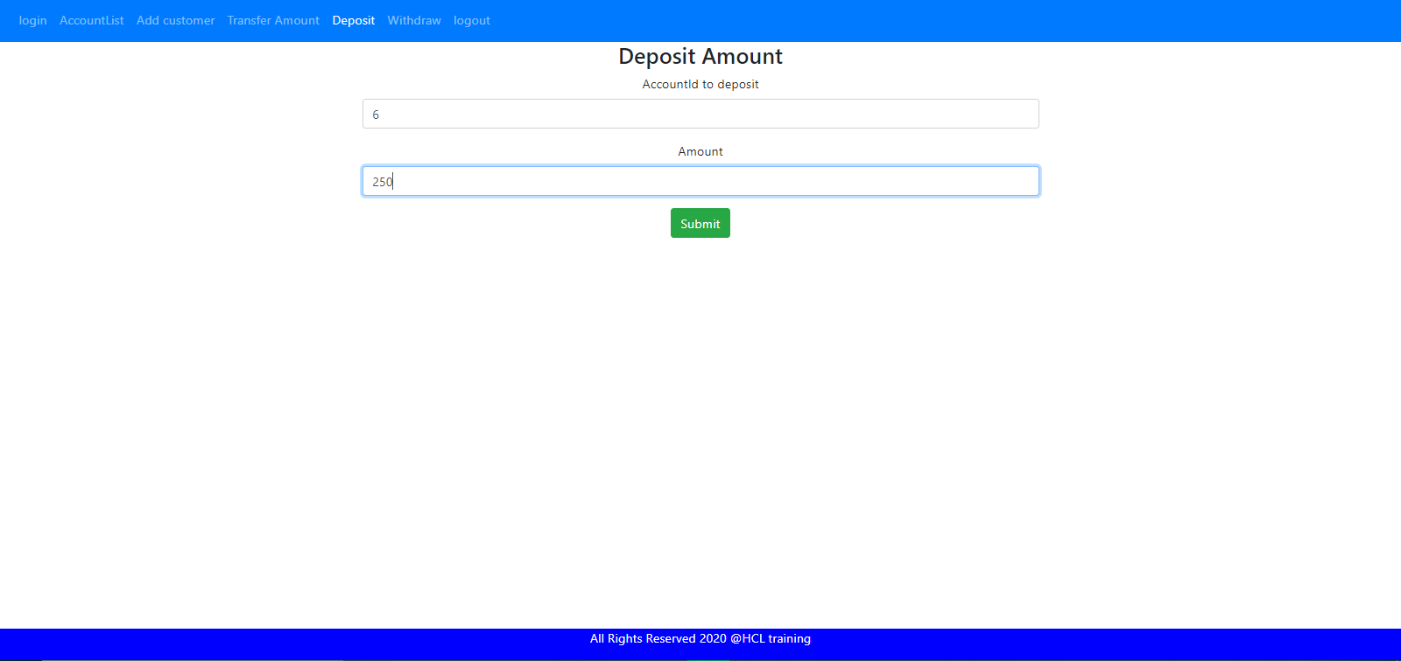

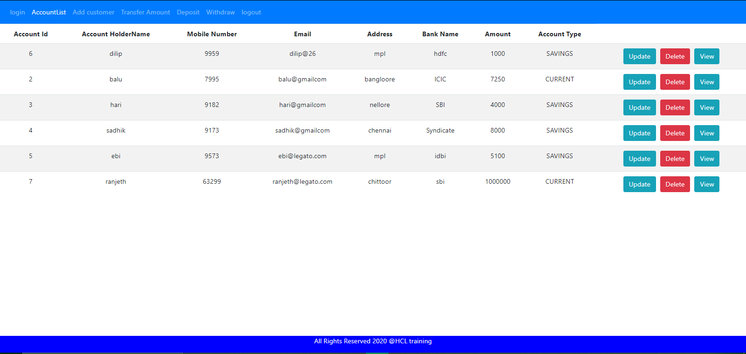

1. Withdrawing the money using Id

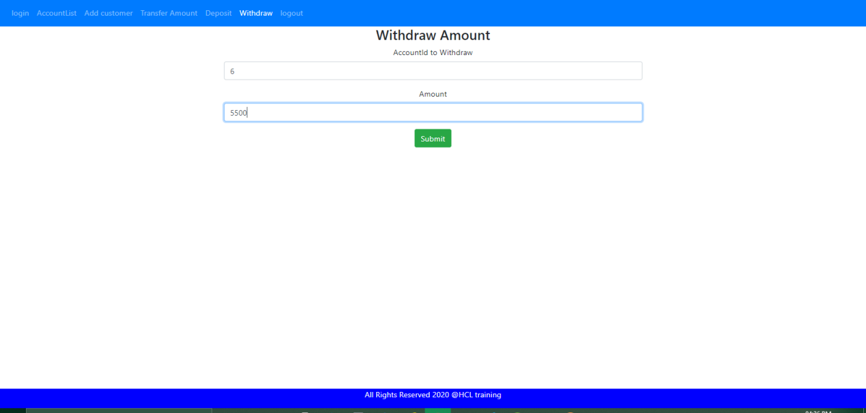

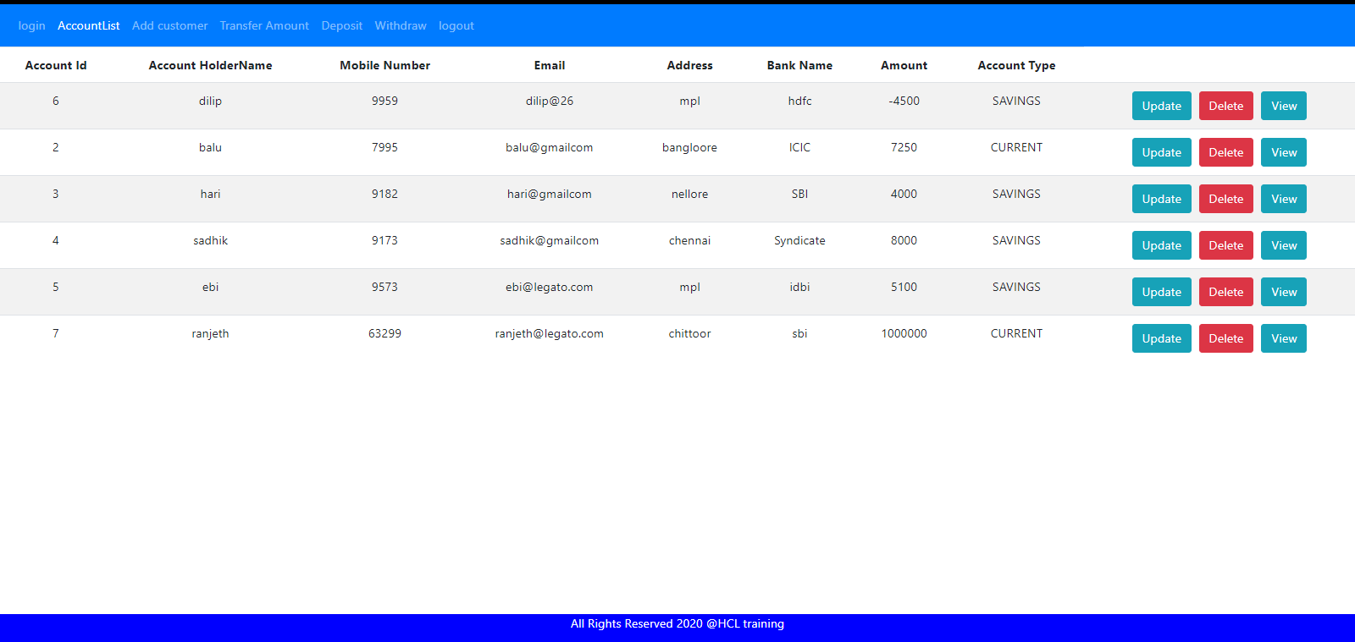

12. After logout

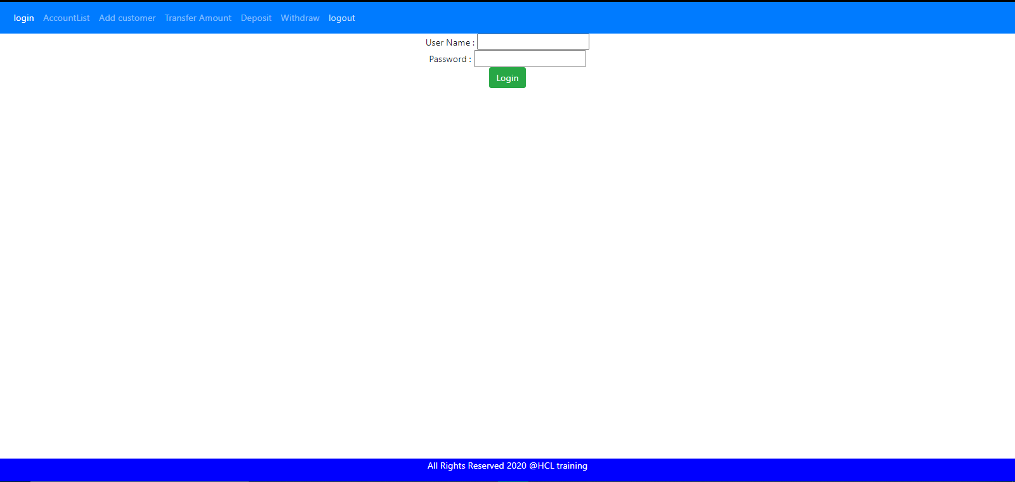

**Code:**

**Account:**

**private** **int** accountId;

**private** String acoountHolderName;

**private** **int** mobileNum;

**private** String email;

**private** String address;

**private** String bankName;

**private** **int** amount;

**private** String accountType;

**Transaction:**

**private** **int** tId;

**private** **int** fromAccount;

**private** **int** toAccount;

@Temporal(TemporalType.***TIMESTAMP***)

**private** Date timeStamp;

**private** **int** tAmount;

**private** String message;

**private** String transType;

@ManyToOne(cascade=CascadeType.***ALL***,fetch=FetchType.***EAGER***)

@JoinColumn

**private** Account account

**Transaction Dao Layer**

import java.util.*;

import com.bankapp.entities.TransactionLog;

public interface TransactionLogRepo {

public TransactionLog addCustomerTransactions(int fromAccountId,int toAccountId,Date timeStamp,String message,int tAmount,String txType);

public TransactionLog addCustomerTransactions(int fromAccountId,Date timeStamp,String message,int tAmount,String txType);

public TransactionLog findByTransactions(int accountId);

List<TransactionLog> getAllTransactionsDetails();

}

**Transaction Dao Implementation**

package com.bankapp.dao;

import java.util.Date;

import java.util.List;

import javax.persistence.EntityManager;

import org.springframework.beans.factory.annotation.Autowired;

import org.springframework.stereotype.Repository;

import com.bankapp.entities.Account;

import com.bankapp.entities.TransactionLog;

@Repository

public class TransactionLogRepoImpl implements TransactionLogRepo{

@Autowired

private EntityManager em;

@Override

public TransactionLog addCustomerTransactions(int fromAccountId, int toAccountId, Date timeStamp, String message,

int tAmount, String txType) {

TransactionLog trasnsactions=new TransactionLog(fromAccountId, toAccountId, timeStamp, message, tAmount, txType);

em.persist(trasnsactions);

return trasnsactions;

}

@Override

public TransactionLog addCustomerTransactions(int fromAccountId, Date timeStamp, String message, int tAmount,

String txType) {

TransactionLog alltrasnsactions=new TransactionLog(fromAccountId, timeStamp, tAmount, message, txType);

em.persist(alltrasnsactions);

return alltrasnsactions;

}

@Override

public TransactionLog findByTransactions(int accountId) {

TransactionLog tansById=em.find(TransactionLog.class, accountId);

return tansById;

}

@Override

public List<TransactionLog> getAllTransactionsDetails() {

return em.createQuery("from TransactionLog").getResultList();

}

}

**AccountServive Implementation**

package com.bankapp.service;

import java.util.Date;

import java.util.List;

import javax.transaction.Transactional;

import org.springframework.beans.factory.annotation.Autowired;

import org.springframework.stereotype.Service;

import com.bankapp.dao.AccountRepo;

import com.bankapp.entities.Account;

import com.bankapp.exceptions.AccountNotFound;

@Service

@Transactional

public class AccountServiceImpl implements AccountService{

@Autowired

private AccountRepo accountRepo;

@Autowired

private TransactionLogService transService;

@Override

public List<Account> getAllCustomerAccounts() {

return accountRepo.findAll();

}

@Override

public Account addCustomerAccount(Account account) {

accountRepo.save(account);

return account;

}

@Override

public Account updateCustomerAccount(int accountId, Account account) {

Account accountToUpdate=getCustomerAccountById(accountId);

accountToUpdate.setAddress(account.getAddress());

accountToUpdate.setEmail(account.getEmail());

accountToUpdate.setAmount(account.getAmount());

accountRepo.save(accountToUpdate);

return accountToUpdate;

}

@Override

public Account deleteCustomerAccount(int accountId) {

Account accountToDelete=getCustomerAccountById(accountId);

accountRepo.delete(accountToDelete);

return accountToDelete;

}

@Override

public Account getCustomerAccountById(int accountId) {

return accountRepo.findById(accountId).orElseThrow(()->new AccountNotFound("Account details not found"));

}

@Override

public String tranferMoney(int fromAccountId, int toAccountId, int amount) {

Account accountFrom=withdrawMoney(fromAccountId,amount);

Account accountTo=depositMoney(toAccountId,amount);

accountRepo.save(accountFrom);

accountRepo.save(accountTo);

transService.addCustomerTransactions(fromAccountId, toAccountId, new Date(), "Success", amount,"debited");

return "transferred";

}

@Override

public Account depositMoney(int accountId, int amount) {

Account amountToDeposit=getCustomerAccountById(accountId);

amountToDeposit.setAmount(amountToDeposit.getAmount()+amount);

accountRepo.save(amountToDeposit);

transService.addCustomerTransactions(accountId, new Date(), "Deposited",amount, "credited");

return amountToDeposit;

}

@Override

public Account withdrawMoney(int accountId, int amount) {

Account amountToWithdraw=getCustomerAccountById(accountId);

amountToWithdraw.setAmount(amountToWithdraw.getAmount()-amount);

accountRepo.save(amountToWithdraw);

transService.addCustomerTransactions(accountId, new Date(), "withdrawn", amount, "debited");

return amountToWithdraw;

}

}

**Transactional Service Implementation**

package com.bankapp.service;

import java.util.Date;

import java.util.List;

import javax.transaction.Transactional;

import org.springframework.beans.factory.annotation.Autowired;

import org.springframework.stereotype.Service;

import com.bankapp.dao.TransactionLogRepo;

import com.bankapp.entities.TransactionLog;

@Service

@Transactional

public class TransactionLogServiceImpl implements TransactionLogService{

@Autowired

private TransactionLogRepo transRepo;

public TransactionLog addCustomerTransactions(int fromAccountId,int toAccountId,Date timeStamp,String message,int tAmount,String txType) {

return transRepo.addCustomerTransactions(fromAccountId, toAccountId, timeStamp, message, tAmount, txType);

}

@Override

public TransactionLog addCustomerTransactions(int fromAccountId, Date timeStamp, String message, int tAmount,

String txType) {

return transRepo.addCustomerTransactions(fromAccountId, timeStamp, message, tAmount, txType);

}

@Override

public TransactionLog findByTransactions(int accountId) {

return transRepo.findByTransactions(accountId);

}

@Override

public List<TransactionLog> getAllTransactionsDetails() {

return transRepo.getAllTransactionsDetails();

}

}

**Controller**

package com.bankapp.controller;

import org.springframework.beans.factory.annotation.Autowired;

import org.springframework.http.HttpStatus;

import org.springframework.http.MediaType;

import org.springframework.http.ResponseEntity;

import org.springframework.web.bind.annotation.CrossOrigin;

import org.springframework.web.bind.annotation.DeleteMapping;

import org.springframework.web.bind.annotation.GetMapping;

import org.springframework.web.bind.annotation.PathVariable;

import org.springframework.web.bind.annotation.PostMapping;

import org.springframework.web.bind.annotation.PutMapping;

import org.springframework.web.bind.annotation.RequestBody;

import org.springframework.web.bind.annotation.RequestMapping;

import org.springframework.web.bind.annotation.RestController;

import com.bankapp.beans.DepositBeans;

import com.bankapp.beans.TransferBeans;

import com.bankapp.beans.WithdrawBeans;

import com.bankapp.entities.Account;

import com.bankapp.entities.TransactionLog;

import com.bankapp.exceptions.TransactionDetailsNotFound;

import com.bankapp.secconfig.AuthResponse;

import com.bankapp.service.AccountService;

import com.bankapp.service.TransactionLogService;

import java.util.*;

@RestController

@CrossOrigin(origins = "*")

public class BankManagerController {

@Autowired

private AccountService accountService;

@Autowired

private TransactionLogService transService;

@GetMapping(path="/accounts",produces=MediaType.APPLICATION_JSON_VALUE)

public ResponseEntity<List<Account>> getCustomerAccount(){

List<Account> allAccounts=accountService.getAllCustomerAccounts();

return new ResponseEntity<List<Account>>(allAccounts,HttpStatus.OK);

}

@GetMapping(path="/accounts/{id}",produces=MediaType.APPLICATION_JSON_VALUE)

public ResponseEntity<Account> getCustomerAccountById(@PathVariable(name="id") int accountId){

Account accountById=accountService.getCustomerAccountById(accountId);

return new ResponseEntity<Account>(accountById,HttpStatus.OK);

}

@PostMapping(path="/accounts",produces=MediaType.APPLICATION_JSON_VALUE,consumes=MediaType.APPLICATION_JSON_VALUE)

public ResponseEntity<Account> addNewCustomerAccount(@RequestBody Account account){

Account accountAdding=accountService.addCustomerAccount(account);

return new ResponseEntity<Account>(accountAdding,HttpStatus.CREATED);

}

@PutMapping(path="/accounts/{id}",produces=MediaType.APPLICATION_JSON_VALUE)

public ResponseEntity<Account> getUpdatedCustomerAccount(@PathVariable(name="id") int accountId,@RequestBody Account account){

Account accountToUpdated=accountService.updateCustomerAccount(accountId, account);

return new ResponseEntity<Account>(accountToUpdated,HttpStatus.CREATED);

}

@DeleteMapping(path="/accounts/{id}",produces=MediaType.APPLICATION_JSON_VALUE)

public ResponseEntity<Void> getCustomerAccountDeleted(@PathVariable(name="id") int accountId){

Account accountToDeleted=accountService.deleteCustomerAccount(accountId);

return new ResponseEntity<Void>(HttpStatus.NO_CONTENT);

}

@PostMapping(path="/accounts/transfer",produces=MediaType.APPLICATION_JSON_VALUE)

public String getTransferDetails(@RequestBody TransferBeans transferBeans) {

String accountTransfer=accountService.tranferMoney(transferBeans.getFromAccountId(), transferBeans.getToAccountId(),transferBeans.getAmount());

if(accountTransfer==null)

return "Not transferred";

else

return "successfully transferred";

}

@PostMapping(path="/accounts/deposit",produces=MediaType.APPLICATION_JSON_VALUE,consumes=MediaType.APPLICATION_JSON_VALUE)

public Account getDepositDetails(@RequestBody DepositBeans depositBeans) {

Account accountToBeDeposited=accountService.depositMoney(depositBeans.getDepositaccountId(), depositBeans.getAmountToDeposit());

return accountToBeDeposited;

}

@PostMapping(path="/accounts/withdraw",produces=MediaType.APPLICATION_JSON_VALUE,consumes=MediaType.APPLICATION_JSON_VALUE)

public Account getWithdrawDetails(@RequestBody WithdrawBeans withdrawBeans) {

Account accountToBeWithdrawn=accountService.withdrawMoney(withdrawBeans.getWithdrawAccountId(), withdrawBeans.getAmountToWithdraw());

return accountToBeWithdrawn;

}

@GetMapping(path="/accounts/transaction",produces=MediaType.APPLICATION_JSON_VALUE)

public List<TransactionLog> getAlTransaction() {

List <TransactionLog> allTrans=transService.getAllTransactionsDetails();

return allTrans;

}

@GetMapping(path="/accounts/transaction/{id}",produces=MediaType.APPLICATION_JSON_VALUE)

public TransactionLog getTransaction(@PathVariable (name="id")int id) {

TransactionLog accountTrans=transService.findByTransactions(id);

return accountTrans;

}

@GetMapping(produces = "application/json")

@RequestMapping({ "/validateLogin" })

public AuthResponse validateLogin() {

return new AuthResponse("User successfully authenticated");

}

}

**Beans:**

**Transfer:**

**private** **int** fromAccountId;

**private** **int** toAccountId;

**private** **int** amount;

**Deposit:**

**private** **int** depositaccountId;

**private** **int** amountToDeposit;

**Withdraw:**

**private** **int** withdrawAccountId;

**private** **int** amountToWithdraw;

**Security Configuration**

package com.bankapp.secconfig;

import org.springframework.beans.factory.annotation.Autowired;

import org.springframework.http.HttpMethod;

import org.springframework.security.config.annotation.authentication.builders.AuthenticationManagerBuilder;

import org.springframework.security.config.annotation.web.builders.HttpSecurity;

import org.springframework.security.config.annotation.web.configuration.EnableWebSecurity;

import org.springframework.security.config.annotation.web.configuration.WebSecurityConfigurerAdapter;

@EnableWebSecurity

public class SecurityConfig extends WebSecurityConfigurerAdapter{

@Override

protected void configure(HttpSecurity http) throws Exception {

http.csrf().disable().

authorizeRequests().antMatchers(HttpMethod.OPTIONS, "/**").permitAll().anyRequest().authenticated()

.and().httpBasic();

}

@Autowired

public void configureGlobal(AuthenticationManagerBuilder auth) throws Exception {

auth.inMemoryAuthentication().withUser("sree").password("{noop}sree123").roles("USER");

}

}

**Angular Code:**

**AccountDetails Class:**

accountId:number;

  acoountHolderName:String

     mobileNum:number;

     email:String;

    address:String;

    bankName:String;

    amount:number;

    accountType:String;

**AccountComponent:**

import { Component, OnInit } from '@angular/core';

import {AccountDetails} from '../accountdetails';

import { AccountService } from '../account.service';

import { Router } from '@angular/router';

@Component({

  selector: 'app-account',

  templateUrl: './account.component.html',

  styleUrls: ['./account.component.css']

})

export class AccountComponent implements OnInit {

  accounts: AccountDetails[];

  constructor(private accountService: AccountService,private router:Router) { }

  ngOnInit() {

    this.getAccounts();

  }

  private getAccounts(){

    this.accountService.getAccountList().subscribe(

      data=>{this.accounts=data});

  }

  updateAccount(id: number){

    console.log(`-----------`)

    this.router.navigate(['update-account', id]);

  }

  deleteAccount(accountId: number){

    this.accountService.deleteAccount(accountId).subscribe(data=>{

      this.getAccounts();

      console.log(data);

    })

  }

  customerDetails(accountId: number){

    this.router.navigate(['customeraccount-details', accountId]);

  }

}

**Account service:**

import { HttpClient } from '@angular/common/http';

import { Injectable } from '@angular/core';

import { from, Observable } from 'rxjs';

import { AccountDetails } from './accountdetails';

import { Deposit } from './deposit';

import { Transfer } from './transfer';

import { Withdraw } from './withdraw';

@Injectable({

  providedIn: 'root'

})

export class AccountService {

  private baseURL="http://localhost:8089/bankapp/accounts";

  constructor(private httpClient: HttpClient) { }

//return this.httpClient.get<Employee[]>(`${this.baseURL}`);

  getAccountList(): Observable<AccountDetails[]>{

    return this.httpClient.get<AccountDetails[]>(`${this.baseURL}`);

  }

  createAccount(account: AccountDetails): Observable<Object>{

    return this.httpClient.post(`${this.baseURL}`, account);

  }

  updateEmployee(accountId: number, account: AccountDetails): Observable<Object>{

    return this.httpClient.put(`${this.baseURL}/${accountId}`, account);

  }

  getAccountById(accountId: number): Observable<AccountDetails>{

    return this.httpClient.get<AccountDetails>(`${this.baseURL}/${accountId}`);

  }

  deleteAccount(accountId: number): Observable<Object>{

    return this.httpClient.delete(`${this.baseURL}/${accountId}`);

  }

   depositAmount(deposit: Deposit): Observable<Object>{

     return this.httpClient.put(`${this.baseURL}`,deposit);

   }

 withdrawAmount(withdraw: Withdraw): Observable<Object>{

  return this.httpClient.put(`${this.baseURL}`,withdraw);

 }

 transferAmount(transfers: Transfer): Observable<Object>{

  return this.httpClient.put(`${this.baseURL}`,transfers);

 }

}

**Create-Account:**

import { Component, OnInit } from '@angular/core';

import { AccountDetails } from '../accountdetails';

import { Router } from '@angular/router';

import { AccountService } from '../account.service';

@Component({

  selector: 'app-create-account',

  templateUrl: './create-account.component.html',

  styleUrls: ['./create-account.component.css']

})

export class CreateAccountComponent implements OnInit {

  account: AccountDetails = new AccountDetails();

  constructor(private accountService: AccountService, private router: Router) { }

  ngOnInit(): void {

  }

  saveAccount(){

    this.accountService.createAccount(this.account).subscribe( data =>{

      console.log(data);

      this.goToAccountList();

    },

    error => console.log(error));

  }

  goToAccountList(){

    this.router.navigate(['/accounts']);

  }

  onSubmit(){

    console.log(this.account);

    this.saveAccount();

  }

}

**HTML Page:**

<div class="col-md-6 offset-md-3">

    <h3> Create Account </h3>

    <form (ngSubmit) = "onSubmit()">

        <div class="form-group">

            <label> Name</label>

            <input type="text" class ="form-control" id = "name"

                [(ngModel)] = "account.acoountHolderName" name = "name">

        </div>

        <div class="form-group">

            <label> MobileNumber </label>

            <input type="text" class ="form-control" id = "mobilenum"

                [(ngModel)] = "account.mobileNum" name = "mobile">

        </div>

        <div class="form-group">

            <label> Email </label>

            <input type="text" class ="form-control" id = "email"

                [(ngModel)] = "account.email" name = "email">

        </div>

              <div class="form-group">

            <label> Address </label>

            <input type="text" class ="form-control" id = "address"

                [(ngModel)] = "account.address" name = "address">

        </div>

              <div class="form-group">

            <label> Bank Name </label>

            <input type="text" class ="form-control" id = "bankname"

                [(ngModel)] = "account.bankName" name = "bankname">

        </div>

        <div class="form-group">

            <label> Amount </label>

            <input type="text" class ="form-control" id = "amount"

                [(ngModel)] = "account.amount" name = "amount">

        </div>

        <div class="form-group">

            <label> Account Type </label>

            <input type="text" class ="form-control" id = "accounttype"

                [(ngModel)] = "account.accountType" name = "accounttype">

        </div>

        <button class = "btn btn-success" type ="submit">Submit</button>

    </form>

    </div>

**Update-Account:**

import { Component, OnInit } from '@angular/core';

import { ActivatedRoute, Router } from '@angular/router';

import { AccountService } from '../account.service';

import { AccountDetails } from '../accountdetails';

@Component({

  selector: 'app-update-account',

  templateUrl: './update-account.component.html',

  styleUrls: ['./update-account.component.css']

})

export class UpdateAccountComponent implements OnInit {

  accountId: number;

  account: AccountDetails = new AccountDetails();

  constructor(private accountService: AccountService,

    private route: ActivatedRoute, private router: Router) { }

  ngOnInit(): void {

    this.accountId=this.route.snapshot.params['accountId'];

   this.accountService.getAccountById(this.accountId).subscribe(data=>{

    this.account=data;

    }, error=>console.log(error))

  }

  onSubmit(){

    this.accountService.updateEmployee(this.accountId, this.account)

    .subscribe(data=> {

        this.goToAccountList();

    }, error=> console.log(error))

  }

goToAccountList(){

    this.router.navigate(['/accounts']);

  }

}

**Html page:**

<div class="col-md-6 offset-md-3">

    <h3> Create Account </h3>

    <form (ngSubmit) = "onSubmit()">

        <div class="form-group">

            <label> Name</label>

            <input type="text" class ="form-control" id = "name"

                [(ngModel)] = "account.acoountHolderName" name = "name">

        </div>

        <div class="form-group">

            <label> MobileNumber </label>

            <input type="text" class ="form-control" id = "mobilenum"

                [(ngModel)] = "account.mobileNum" name = "mobile">

        </div>

        <div class="form-group">

            <label> Email </label>

            <input type="text" class ="form-control" id = "email"

                [(ngModel)] = "account.email" name = "email">

        </div>

              <div class="form-group">

            <label> Address </label>

            <input type="text" class ="form-control" id = "address"

                [(ngModel)] = "account.address" name = "address">

        </div>

              <div class="form-group">

            <label> Bank Name </label>

            <input type="text" class ="form-control" id = "bankname"

                [(ngModel)] = "account.bankName" name = "bankname">

        </div>

        <div class="form-group">

            <label> Amount </label>

            <input type="text" class ="form-control" id = "amount"

                [(ngModel)] = "account.amount" name = "amount">

        </div>

        <div class="form-group">

            <label> Account Type </label>

            <input type="text" class ="form-control" id = "accounttype"

                [(ngModel)] = "account.accountType" name = "accounttype">

        </div>

        <button class = "btn btn-success" type ="submit">Submit</button>

    </form>

    </div>

**AccountDetails:**

import { Component, OnInit } from '@angular/core';

import { ActivatedRoute } from '@angular/router';

import { AccountService } from '../account.service';

import { AccountDetails } from '../accountdetails';

@Component({

  selector: 'app-customeraccount-details',

  templateUrl: './customeraccount-details.component.html',

  styleUrls: ['./customeraccount-details.component.css']

})

export class CustomeraccountDetailsComponent implements OnInit {

accountId: number;

account: AccountDetails=new AccountDetails();

  constructor(private accountService: AccountService,

    private router: ActivatedRoute) { }

    ngOnInit(): void {

      this.accountId = this.router.snapshot.params['accountId'];

      this.account=new AccountDetails();

  this.accountService.getAccountById(this.accountId).subscribe(data=>{

    this.account=data;

  });

}

}

**AppComponent.HTML**

<nav class="navbar navbar-expand-sm bg-primary navbar-dark">

  <ul class = "navbar-nav">

    <li class = "nav-item">

      <a [routerLink]="['/login']" routerLinkActive="active" class="nav-link" >login</a>

  </li>

      <li class = "nav-item">

          <a [routerLink]="['/accounts']" routerLinkActive="active" class="nav-link" >AccountList</a>

      </li>

      <li class = "nav-item">

        <a  [routerLink]="['/create-account']" routerLinkActive="active" class="nav-link" >Add customer</a>

      </li>

      <li class = "nav-item">

        <a  [routerLink]="['/transfer']" routerLinkActive="active" class="nav-link" >Transfer Amount</a>

      </li>

      <li class = "nav-item">

        <a  [routerLink]="['/deposit']" routerLinkActive="active" class="nav-link" >Deposit</a>

      </li>

      <li class = "nav-item">

        <a  [routerLink]="['/withdraw']" routerLinkActive="active" class="nav-link" >Withdraw</a>

      </li>

      <li class = "nav-item">

        <a   [routerLink]="['/logout']" routerLinkActive="active" class="nav-link" >logout</a>

      </li>

  </ul>

</nav>

<div class="text-center">

  <router-outlet></router-outlet>

</div>

<footer class = "footer">

  <div class = "container">

      <span>All Rights Reserved 2020 @HCL training</span>

  </div>

</footer>

**App routing Module**

import { NgModule } from '@angular/core';

import { Routes, RouterModule } from '@angular/router';

import { AccountComponent } from './account/account.component';

import { AuthGaurdService } from './auth-gaurd.service';

import { CreateAccountComponent } from './create-account/create-account.component';

import { CustomeraccountDetailsComponent } from './customeraccount-details/customeraccount-details.component';

import { DepositComponent } from './deposit/deposit.component';

import { LoginComponent } from './login/login.component';

import { LogoutComponent } from './logout/logout.component';

import { TransferComponent } from './transfer/transfer.component';

import { UpdateAccountComponent } from './update-account/update-account.component';

import { WithdrawComponent } from './withdraw/withdraw.component';

const routes: Routes = [

  {path:'accounts', component: AccountComponent,canActivate:[AuthGaurdService]},

  {path:'create-account', component: CreateAccountComponent,canActivate:[AuthGaurdService]},

  {path:'update-account/:accountId', component: UpdateAccountComponent,canActivate:[AuthGaurdService]},

  {path:'customeraccount-details/:accountId', component: CustomeraccountDetailsComponent,canActivate:[AuthGaurdService]},

  {path:'transfer', component: TransferComponent,canActivate:[AuthGaurdService]},

  {path:'deposit', component: DepositComponent,canActivate:[AuthGaurdService]},

  {path:'withdraw', component: WithdrawComponent,canActivate:[AuthGaurdService]},

  { path: 'login', component: LoginComponent },

  { path: 'logout', component: LogoutComponent ,canActivate:[AuthGaurdService]},

  {path:'', redirectTo:'accounts', pathMatch:'full'}

];

@NgModule({

  imports: [RouterModule.forRoot(routes)],

  exports: [RouterModule]

})

export class AppRoutingModule { }

**Authentication:**

import { HttpClient, HttpHeaders } from '@angular/common/http';

import { Injectable } from '@angular/core';

import { map } from 'rxjs/operators';

export class AuthResponse{

  constructor(public status:string) {}

}

@Injectable({

  providedIn: 'root'

})

export class AuthenticationService {

  constructor(private httpClient:HttpClient) {  }

  authenticate(username, password) {

    const headers = new HttpHeaders({ Authorization: 'Basic ' + btoa(username + ':' + password) });

    return this.httpClient.get<AuthResponse>('http://localhost:8089/bankapp/validateLogin',{headers}).pipe(

      map(

        userData => {

          sessionStorage.setItem('username', username);

          let authString = 'Basic ' + btoa(username + ':' + password);

          sessionStorage.setItem('basicauth', authString);

          return userData;

        }

      )

    );

  }

  isUserLoggedIn() {

    let user = sessionStorage.getItem('username')

    console.log(!(user === null))

    return !(user === null)

  }

  logOut() {

    sessionStorage.removeItem('username')

  }

}

**AuthGuard service:**

import { Injectable } from '@angular/core';

import { ActivatedRouteSnapshot, CanActivate, Router, RouterStateSnapshot } from '@angular/router';

import { AuthenticationService } from './authentication.service';

@Injectable({

  providedIn: 'root'

})

export class AuthGaurdService implements CanActivate{

  constructor(private router: Router,

    private authService: AuthenticationService) { }

  canActivate(route: ActivatedRouteSnapshot, state: RouterStateSnapshot) {

    if (this.authService.isUserLoggedIn())

      return true;

    this.router.navigate(['login']);

    return false;

  }

}

**Basic AuthInterceptor:**

import { Injectable } from '@angular/core';

import { HttpInterceptor, HttpRequest, HttpHandler } from '@angular/common/http';

@Injectable({

  providedIn: 'root'

})

export class BasicAuthHtppInterceptorService implements HttpInterceptor {

  constructor() { }

  intercept(req: HttpRequest<any>, next: HttpHandler) {

    if (sessionStorage.getItem('username') && sessionStorage.getItem('basicauth')) {

      req = req.clone({

        setHeaders: {

          Authorization: sessionStorage.getItem('basicauth')

        }

      })

    }

    return next.handle(req);

  }

}

**Login:**

import { Component, OnInit } from '@angular/core';

import { Router } from '@angular/router';

import { AuthenticationService } from '../authentication.service';

@Component({

  selector: 'app-login',

  templateUrl: './login.component.html',

  styleUrls: ['./login.component.css']

})

export class LoginComponent implements OnInit {

  username = ''

  password = ''

  invalidLogin = false

  constructor(private router: Router,

    private loginservice: AuthenticationService) { }

  ngOnInit() {

  }

  checkLogin() {

    (this.loginservice.authenticate(this.username, this.password).subscribe(

      data => {

        this.router.navigate([''])

        this.invalidLogin = false

      },

      error => {

        this.invalidLogin = true

      }

    )

    );

  }

}

**Logout:**

import { Component, OnInit } from '@angular/core';

import { Router } from '@angular/router';

import { AuthenticationService } from '../authentication.service';

@Component({

  selector: 'app-logout',

  templateUrl: './logout.component.html',

  styleUrls: ['./logout.component.css']

})

export class LogoutComponent implements OnInit {

  constructor(

    private authentocationService: AuthenticationService,

    private router: Router) {

  }

  ngOnInit() {

    this.authentocationService.logOut();

    this.router.navigate(['login']);

  }

}